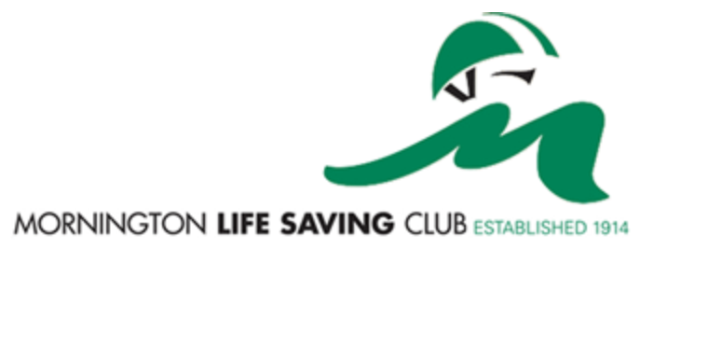

Swim assessment waiver form. U/11

To the junior skills evaluator at Mornington Life Saving Club.

I ………………………………….... Hereby state that my child …………………………………......
Parents name Child's name

Is a renewing member of the Mornington Lifesaving club in 2018/19 and has been assessed by a qualified swim teacher/coach to be able to swim 50 m continuous freestyle and can complete 2 minutes of survival float.

Swim coach/instructors name ……..............................................................

Swim school /club …………………………………………………………………………………..

Swim coach Signature ……………………………………………Date………………………….

Parents signature…………………………………………………. Date………………………...

NB: Swim coach/assessor must hold AUSTSWIM qualifications or be a qualified Bronze medallion assessor

