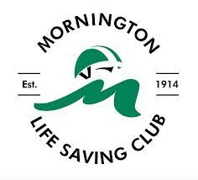

Mornington Life Saving Club
2025 - 2026 Annual General Meeting

Held in Clubroom
On Friday 19th June 2026 6.30PM
Agenda

- Minutes:
  - 2025 AGM – Monday 28th July 2025
- Financial Report for the year ending 31st March 2026
  - Auditor’s Report
  - Treasurer’s Report
  - Questions/Answers
- Governance Report
- Membership Report
- President’s Report
- Club Captain’s Report
- Senior Captain’s Report
- Schools Program Report
- Nipper Captain’s Report
- Chief Instructor’s Report
- Facilities, Equipment & Assets Report
- 2025/26 Challenges & Risks
- 2026/27 Priorities
- Acknowledgements & Thanks
- 2026/27 Office Bearer Elections
- Any Other Business

