Overview

- The MobiChair beach wheelchair is designed for use on the beach (on hard or soft sand), on grass or surfaced footpaths, in low water, and to float in shallow water levels.

- The MobiChair beach wheelchair is to ONLY be used at Mills Beach and where there is at least one support person accompanying the occupant at all times.

- The chair is designed to be able to access low levels of water to aid floating.

- Water level should not exceed waist height of the support people.

- The wheelchair is not to be used in deep water and ONLY between the flags as patrolled by the Life Saving Club.

- When entering the water to float, it is required that TWO assistants are present.

- The MobiChair is not intended for areas with currents or strong waves and the SLSC may at any time determine that conditions make it unsafe for use.

- The SLSC will require the user to return the MobiChair immediately where any person fails to comply with these Conditions of Use.

NOTE that there is currently no hoist available for transfer, and this is not an independent chair, therefore please ensure you have the right level of support to transfer and push the beach wheelchair.

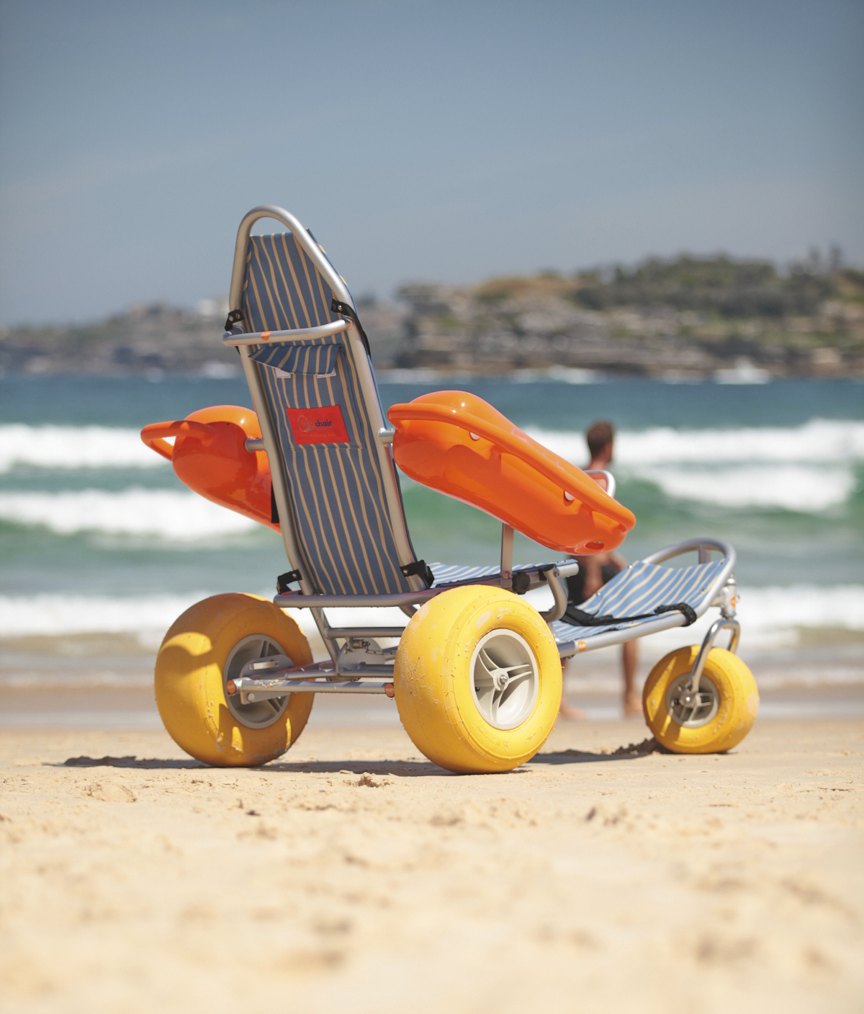
For further details about accessible beaches visit: https://accessiblebeaches.com/directory/#accessible-beach-directory

For information about the MobiChair wheelchair visit: http://pushmobility.com.au/shop/mobi-chair-floating-beachwheelchair

It is important to be prepared before you head out in the beach wheelchair

Please read this document in full including signing the safety procedures checklist (attached) prior to using the wheelchair.

MobiChair Beach Wheelchair – Safety Procedures

Before use

- Check the weather for incoming tides as well as the strength of the waves, wind strength, storms and heat prior to hiring the wheelchair. The staff at the Life Saving Club will be able to provide you with helpful information about weather conditions and suitability for the beach wheelchair.

- Ensure walkway / routes to be taken are clear of hazards.

- Visually inspect seating, tyres and moving parts for possible damage and report same to the SLSC immediately.

- Ensure the support person(s) stabilise the wheelchair so that it will not move when a person is being seated.

- NOTE that there is currently no hoist available for transfer, please ensure you have the right level of support to transfer and push the beach wheelchair.

- If you are not experienced at lifting, it may be useful to approach a local rehabilitation centre, hospital or physiotherapist regarding training for transferring and lifting.

During use

- The wheelchair has been designed to be used on dry sand, wet sand, at the water’s edge and to float in shallow water levels up to waist height of the support person, in still water conditions.

- The MobiChair will begin to float as the water level reaches half way up the balloon tyres. At this point the user will notice a small tilt backwards as the chair transitions into the floating position.

- When entering waist height waters to float, it is required that two assistants are present. It is important the tide and waves are monitored throughout the period of use.

- The wheelchair is NOT to be used in deep water beyond waist height of the support persons.

- Do not exceed maximum recommended loading of 150kg.

- It is recommended for the user securely fastens all harnesses to ensure safe and stable positioning. The can easily be adjusted in length to create a suitable fit.

- The backrest angle can be adjusted into three positions by pulling the looped chain located at the back of the chair behind the backrest.

- Do not leave a person unattended when in the wheelchair when parking and find a level surface to park on.

- Gradients steeper than a standard ramp rise are not recommended unless two people are assisting with pushing/pulling the chair. It is recommended one assistant pulls using the tow rope at the front, whilst the second assistant pushes from behind.

- Ensure heavy items are not placed on back of wheelchair.

- Always keep the person informed about what you are intending to do (turning, entering water, crossing road).

- The wheelchair is not designed for self-propelling (independent use) and must be supervised and pushed by a responsible assistant

- The wheelchair must not be propelled by towing behind a motor vehicle, kite or other means, other than being pushed/pulled by support persons.

- When in water, the use of the safety belt is recommended, depending on the person’s understanding of their capacity to move around freely. If a passenger experiences unsteadiness (such as with epilepsy) the seat belt should be used.

- Always use the safety belt when using the chair on dry land, including soft and hard sand. If a passenger experiences unsteadiness (such as epilepsy) the seat belt should be used at all times.

- The wheelchair is not to be removed from the designated beach area.

After Use

- Where possible the user should use a shower or hose to clean down the chair before returning to the Life Saving Club.

- Any safety, mechanical or accessibility concerns with the use of the beach wheelchair should be reported immediately to the Life Saving Club We welcome your feedback on your experience and use.

For more information about accessible recreation on the Mornington Peninsula:
https://www.mornpen.vic.gov.au/Community-Services/Disability-Services/Activities/Accessible-Recreation
Safety Procedure checklist for user to complete prior to use of the MobiChair wheelchair

Have you (please tick):

□ Read and understood the wheelchair safety procedures

□ Been provided with a demonstration on how to use the wheelchair

□ Checked back rest adjustment, seat belt harness and general condition of the wheelchair

□ Noted the low water instructions

□ Understood the requirement to engage TWO assistants if entering the water to float

□ Checked weather conditions such as wind strength, incoming tides, possible storms, heat

□ Checked the lifesaving flags are in operation

□ Provided an approximate time to return the beach wheelchair

ACKNOWLEDGMENT

I acknowledge that I am the **user / **nominated support person for the occupier of the MobiChair beach wheelchair.

Upon hiring the wheelchair, I accept responsibility for the safe use of the wheelchair in accordance with the Conditions of Use and agree to indemnify Mornington Peninsula Shire against any claim relating to the use of the wheelchair howsoever arising.

For support person only: In addition to the above acknowledgment, I further agree to physically remain with the occupier of the wheelchair at all times for the duration of the use period.

Name of user/support person ………………………………………………

Signature……………………………………………. Date …./…./…

Name of Life Saving Club representative …………………………………....

Signature ……………………………………………..Date …./…./….

**delete whichever does not apply

